Budget Bridge
Architecture/Design Document

Table of Contents
1 Introduction 3
2 Software architecture (High-Level Overview) 4
3 MAIN USER Task Workflow 4

Introduction
This document describes the architecture and design for the Budget Bridge web application being developed for the Commerce Bank group project in the University of Missouri—Kansas City’s (UMKC) Software Engineering Capstone (CS-451R) course. Budget Bridge is a personal budging web application that allows users to track their income and expenses, so they can manage and improve their spending habits.

The purpose of this document is to describe the architecture and design of Budget Bridge web application.

Software Architecture (High-Level Overview)
This diagram below explains the tech stack used in developing the Budget Bridge web application.
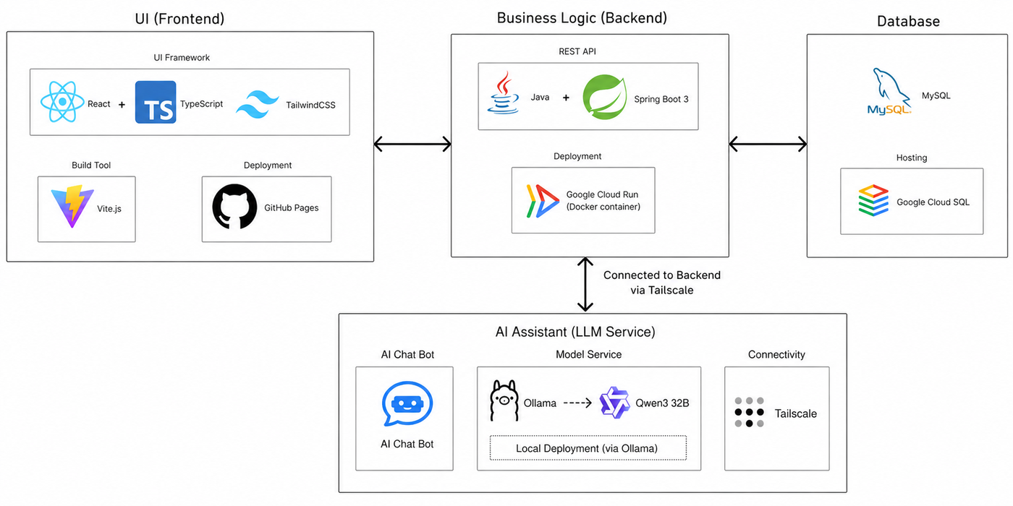
https://www.figma.com/design/tOGigtAzyLe5zX4fDlgKLI/Budget-Bridge-architecture?node-id=0-1&t=AfsxbPaNuDEoWUl0-1

Frontend
- React 19 + TypeScript – UI Framework
- Vite – Build Tool / Dev Server
- React Routine – client sider routing
- Tailwind CSS – styling
- Recharts – data visualizations
- Deployment: GitHub Pages
Backend
- Java + Spring Boot 3 – REST API
- Spring Security – authentication / session management
- Spring Boot JPA / Hibernate – ORM
- Spring Mail –email via Email SMTP
- Deployment: Google Cloud Run (Docker Container)
Database
- MySQL – hosted on Google Cloud SQL

Main User Task Flow
This section describes Budget Bridge’s data flow, integration points and an overview of how users navigate through the main parts of the web application.
